SIMATS ENGINEERING
ASSESSMENT TOOL 2

COURSE CODE: CSA14 COURSE NAME: Compiler Design

COURSE OUTCOME COVERED

CO1: Apply lexical analysis for token specification and recognition using LEX tool (BL3)

Assessment Tool Weightage: 20%

QUESTIONS: 3 Total Marks:50

Annexure A

ERROR ANALYSIS TASK

Code of Conduct:

I ___S.KRISHNA(192511033)______ (Name / Reg No) certify that this submission is my original work and that I have adhered to the guidelines specified for this assessment.
I understand that any violation of academic integrity rules will result in disciplinary action.

S.KRISHNA
Signature of the student:

Annexure A

ERROR ANALYSIS TASK

Q1. The following program is intended to perform simple arithmetic operations, function calls, array access, and looping constructs. However, the code contains multiple errors introduced at different phases of compilation, including lexical, syntax, semantic, logical, and runtime errors.
Given Program
#include <stdio.h>

int sumArray(int arr[], int n) {
int i, sum = 0;
for(i = 0; i <= n; i++) {
sum = sum + arr[i];
}
return sum;
}

int main() {
int arr[5] = {1,2,3,4,5}
int total;

total = sumArray(arr);

if(total == 15) {
printf("Correct Sum\n")
}

int a = 10, b = 0;
int c = a / b;

int *p;
*p = 20;

return 0;
}
Tasks:
(a) Error Identification (Analysis Level)
- Identify all the errors present in the program. For each error:
- Specify the line number
- Clearly describe the nature of the error
(b) Classification of Errors (Understanding + Analysis)
- Classify each identified error into the appropriate compiler phase:
- Lexical Errors
- Syntax Errors
- Semantic Errors
- Logical Errors
- Runtime Errors
(c) Compilation Behavior (Evaluation Level)
- Analyze which errors will be detected during compilation and which will only appear during execution.
- Explain how early-stage errors (lexical/syntax) may prevent detection of later-stage errors.
(d) Code Correction (Application Level)
- Rewrite the corrected version of the program such that:
- All errors are removed
- The program executes correctly
- Proper syntax and semantics are maintained
(e) Impact Analysis (Evaluation Level)
- Discuss the impact of at least three errors on program execution.
- Explain how incorrect constructs like improper pointer usage, division by zero, and infinite loops affect system behavior.
(f) Advanced Compiler Perspective (Create Level)
- Suggest how a compiler can be improved to:
- Provide better error messages
- Perform early detection of runtime errors
- Propose at least two enhancements in compiler design for efficient debugging.

ANSWER:
DESCRIPTION:
The question focuses on analyzing a C program that contains different types of errors. It requires identifying and describing the errors with their line numbers and classifying them as lexical, syntax, semantic, logical, or runtime errors. It also asks us to understand which errors are detected during compilation and which occur during program execution. The faulty program must be corrected to make it execute properly. Finally, the question requires discussing the impact of major errors and suggesting compiler improvements for better error detection and debugging.

(a) Error Identification
- Line 6: i <= n – accesses the array outside its valid range.
- Line 9: Missing ; after array declaration.
- Line 11: sumArray(arr) – missing the second argument n.
- Line 13: Missing ; after printf().
- Line 17: Division by zero because b = 0.
- Line 19: Uninitialized pointer p is dereferenced.
(b) Compilation Behavior
Syntax and semantic errors are detected during compilation. Logical errors may pass compilation. Division by zero and invalid pointer access can occur during execution. Early syntax errors may prevent the compiler from properly analyzing later code.
(c) Corrected Code
#include <stdio.h>

int sumArray(int arr[], int n) {
int i, sum = 0;
for(i = 0; i < n; i++)
sum += arr[i];
return sum;
}

int main() {
int arr[5] = {1,2,3,4,5};
int total = sumArray(arr, 5);

if(total == 15)
printf("Correct Sum\n");

int a = 10, b = 0;
if(b != 0)
printf("%d\n", a / b);
else
printf("Division by zero\n");

int x;
int *p = &x;
*p = 20;

return 0;
}
(d) Impact Analysis
- Division by zero: Causes undefined behavior or program failure.
- Invalid pointer: Can cause a crash or memory corruption.
- Array out-of-bounds: Can produce incorrect results or undefined behavior.
- Infinite loop: Can continuously consume CPU and make the program unresponsive.
(e) Compiler Improvements
- Static analysis can detect possible runtime errors early.
- Better diagnostics can provide exact line numbers and correction suggestions.
- Runtime sanitizers can detect invalid memory access and other execution problems.
CORRECTED CODE:
#include <stdio.h>
int sumArray(int arr[], int n)
{
int i, sum = 0;
for (i = 0; i < n; i++)
{
sum = sum + arr[i];
}
return sum;
}
int main()
{
int arr[5] = {1, 2, 3, 4, 5};
int total;
total = sumArray(arr, 5);
if (total == 15)
{
printf("Correct Sum\n");
}
int a = 10, b = 2;
int c = a / b;
printf("Division result = %d\n", c);
int value;
int *p = &value;
*p = 20;
printf("Pointer value = %d\n", value);
return 0;
}
OUTPUT:
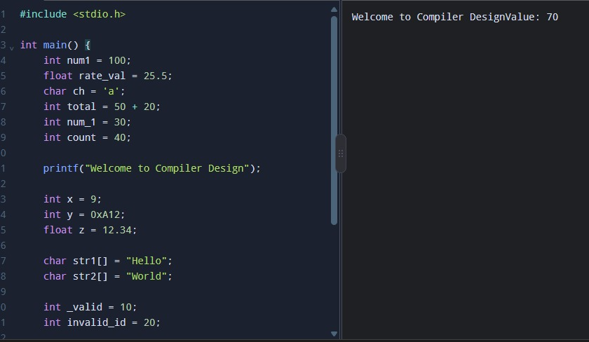

Q2.The following C program contains multiple lexical errors introduced intentionally. These errors occur due to invalid tokens, incorrect identifiers, malformed constants, and illegal symbols, which are typically detected during the lexical analysis phase of a compiler.Carefully examine the program and answer the questions given below.
#include <stdio.h>

int main() {
int 1num = 100;
float rate@ = 25.5;
char ch = 'abc';
int total = 50$20;
int num#1 = 30;
int %count = 40;

printf("Welcome to Compiler Design);

int x = 09;
int y = 0xZ12;
int z = 12.3.4;

char str1[] = "Hello;
char str2[] = "World";

int _valid = 10;
int invalid-id = 20;

float value = 5..6;
int data = 10@5;

char c = 'xy';
int 3value = 60;

printf("Value: %d\n", total);

return 0;
}
Tasks
(a) Error Identification
i) Identify all lexical errors in the program.
ii) List the line number and the invalid token.
(b) Error Classification
i) For each error, explain why it is considered a lexical error.
ii) Specify which rule of token formation is violated:
iii) Identifier rules
iv) Constant formation
v) String/character literal rules
vi) Operator/symbol rules
(c) Token Correction
i)Rewrite each invalid token into a valid token.
ii)Example: 2value → value2
(d) Compiler Behavior Analysis
i) Explain how a lexical analyzer (scanner) processes such errors.
ii)Discuss whether the compiler:
iii)Stops immediately
iv)Continues scanning using error recovery
(e) Advanced Thinking
i) Design a simple rule (or DFA idea) to detect invalid identifiers starting with digits.
ii) Suggest how error messages can be improved for beginners.

ANSWER:
Description
The given C program contains intentionally introduced lexical errors such as invalid identifiers, malformed numeric constants, invalid symbols, and incorrect string/character literals. The question focuses on how the lexical analyzer (scanner) identifies invalid tokens and how these tokens can be corrected.
(a) Error Identification
Line | Invalid Token | Error
3 | 1num | Identifier cannot start with a digit
4 | rate@ | @ is an invalid identifier character
5 | 'abc' | Invalid character constant; contains multiple characters
6 | 50$20 | $ is not a valid C operator/symbol
7 | num#1 | # is invalid inside an identifier
8 | %count | % cannot start an identifier
9 | "Welcome to Compiler Design) | Unterminated string literal
10 | 09 | Invalid octal constant
11 | 0xZ12 | Invalid hexadecimal constant
12 | 12.3.4 | Malformed floating-point constant
13 | "Hello | Unterminated string literal
15 | invalid-id | - is interpreted as an operator, not part of an identifier
16 | 5..6 | Malformed floating-point constant
17 | 10@5 | @ is an invalid symbol in this expression
18 | 'xy' | Invalid character constant; contains multiple characters
19 | 3value | Identifier cannot start with a digit
Note: int _valid = 10; on line 14 is valid in C because an identifier can begin with an underscore.

(b) Error Classification
1. Identifier Rule Violations
- 1num
- rate@
- num#1
- %count
- invalid-id
- 3value
These violate C identifier rules. Identifiers can contain letters, digits, and underscores, but cannot begin with a digit.
2. Constant Formation Errors
- 09
- 0xZ12
- 12.3.4
- 5..6
These do not follow valid integer, hexadecimal, or floating-point constant formats.
3. String/Character Literal Errors
- 'abc'
- "Welcome to Compiler Design)
- "Hello
- 'xy'
Character literals should normally contain one character, while strings must have matching double quotes.
4. Operator/Symbol Errors
- 50$20
- 10@5
$ and @ are not valid operators in standard C expressions.

(c) Token Correction
Invalid Token | Correct Token
1num | num1
rate@ | rate
'abc' | "abc"
50$20 | 50 + 20
num#1 | num1
%count | count
"Welcome to Compiler Design) | "Welcome to Compiler Design"
09 | 9
0xZ12 | 0x12
12.3.4 | 12.34
"Hello | "Hello"
invalid-id | invalid_id
5..6 | 5.6
10@5 | 10 + 5
'xy' | 'x'
3value | value3

(d) Compiler Behavior Analysis
The lexical analyzer reads the source program character by character and groups characters into tokens such as identifiers, keywords, constants, operators, and literals.
When an invalid token is found, the scanner generates a lexical error with the line number and location. A compiler may either stop immediately or use error recovery to skip the invalid characters and continue scanning to find additional errors.
For example:
Line 3: Invalid identifier '1num'
Line 10: Invalid octal constant '09'
Modern compilers generally try to report multiple errors in one compilation instead of stopping at the first error.

(e) Advanced Thinking
1. DFA Rule for Invalid Identifiers
A simple rule is:
First character → Letter or _
Next characters → Letter, Digit, or _
If the first character is a digit:
Digit + Letter → Invalid identifier
Example:
3value → Invalid
value3 → Valid
2. Improved Error Messages
For beginners, the compiler should provide:
- Exact line and column number
- The invalid token
- Simple explanation
- Correct example
- Suggested correction
Example:
Error: Line 19
'3value' is an invalid identifier.
Identifiers cannot start with a digit.
Suggestion: Rename it to 'value3'.
Conclusion: The program demonstrates how lexical analysis detects invalid tokens before syntax and semantic analysis. Correct token formation and clear compiler messages help programmers identify and fix errors quickly.

CORRECTED CODE:

#include <stdio.h>
int main()
{
int num = 100;
float rate = 25.5;
char ch = 'a';
int total = 50 + 20;
int num1 = 30;
int count = 40;
printf("Welcome to Compiler Design");
int x = 9;
int y = 0x12;
int z = 12;
char str1[] = "Hello";
char str2[] = "World";
int _valid = 10;
int invalid_id = 20;
float value = 5.6;
int data = 10 + 5;
char c = 'x';
int value3 = 60;
printf("Value: %d\n", total);
return 0;
}
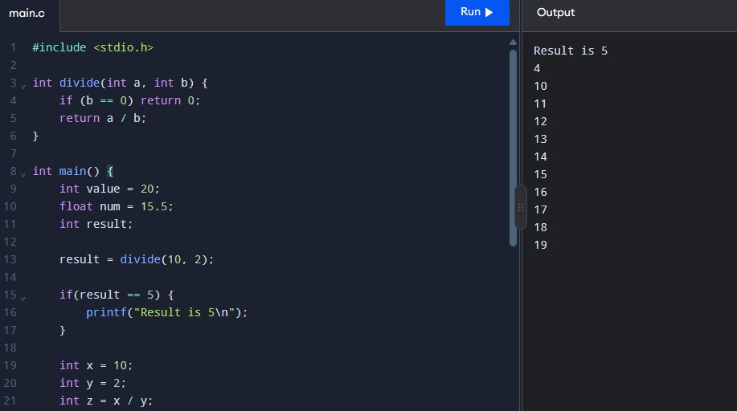
OUTPUT:
Q3. The following C program is designed to perform arithmetic operations, function calls, conditional checks, pointer usage, and looping. However, the program contains multiple errors distributed across different phases of a compiler, including:
- Lexical Errors
- Syntax Errors
- Semantic Errors
- Intermediate Code Generation Issues (logic/precedence)
- Code Optimization Issues (redundancy/inefficiency)
- Runtime / Target Code Errors
Carefully analyze the program and answer the questions below.

#include <stdio.h>

int divide(int a, int b) {
return a / b
}

int main() {
int #value = 20;
float num = 15.5
int result;

result = divide(10);

if(result = 5) {
printf("Result is 5\n")
}

int x = 10;
int y = 0;
int z = x / y;

int arr[4] = {1,2,3,4};
printf("%d\n", arr[4]);

int *ptr;
*ptr = 25;

int total;
total = x + y * result + 0;

while(x < 20) {
printf("%d\n", x);
}

return 0;
}
Do the following Tasks
(a) Identify Errors (Analysis Level)
- Identify all errors in the program.
- Mention line number + error description.

(b) Classify by Compiler Phase
Classify each error into:
- Lexical (invalid symbols like @num)
- Syntax (missing semicolon, brackets)
- Semantic (function argument mismatch)
- Intermediate Code Issues (wrong expression handling/precedence)
- Optimization Issues (redundant + 0)
- Runtime Errors (division by zero, invalid pointer access)

(c) Compilation vs Execution (Evaluation)
- Which errors are detected at compile time?
- Which errors appear only during execution?
- Explain why some errors prevent further compilation.

(d) Correct the Program (Application)
- Rewrite the fully corrected program.
- Ensure:
  - Proper syntax
  - Correct semantics
  - Safe execution

(e) Deep Analysis (Evaluation)
- Explain how incorrect pointer usage affects runtime.
- Analyze how array bounds violation impacts memory.
- Discuss how operator precedence errors affect intermediate code.

(f) Advanced Task (Create Level)
- Suggest 2 improvements in compiler design to:
  - Detect runtime errors earlier
  - Improve debugging messages
- Propose how optimization phase can remove redundant expressions.

RUBRICS FOR CALCULATION:

Criteria | Weightage | Level 4 (Exemplary) | Level 3 (Proficient) | Level 2 (Developing) | Level 1 (Beginning)
Error Identification | 20% | Accurately identifies all errors with clear understanding of issues | Identifies most errors with minor omissions | Identifies limited errors; some are missed | Fails to identify key errors
Root Cause Analysis | 30% | Clearly explains underlying causes with strong technical reasoning | Explains causes with moderate clarity | Partial explanation; weak reasoning | Unable to identify causes of errors
Correction & Justification | 25% | Provides correct solutions with strong justification and logic | Provides correct corrections with some justification | Corrections are partially correct or weakly justified | Incorrect or no corrections provided
Application of Concepts | 15% | Effectively applies relevant concepts to analyze and resolve errors | Applies concepts with minor errors | Limited application; requires guidance | Unable to apply concepts
Clarity & Presentation | 10% | Presents analysis clearly, logically, and systematically | Generally clear with minor issues | Lacks clarity or proper structure | Poor presentation and difficult to understand

ANSWER:
Description
The program performs arithmetic, function calls, conditions, arrays, pointers, and loops. It contains different errors from lexical, syntax, semantic, optimization, logical, and runtime phases. The objective is to identify, classify, correct, and understand their effects.
(a) Error Identification
- Line 4: Missing ; after return a / b – Syntax error.
- Line 9: #value is an invalid identifier – Lexical error.
- Line 10: Missing ; after 15.5 – Syntax error.
- Line 12: divide(10) has a missing argument – Semantic error.
- Line 14: result = 5 should be result == 5 – Logical error.
- Line 15: Missing ; after printf() – Syntax error.
- Line 20: x / y with y = 0 – Runtime error.
- Line 22: arr[4] is outside the array range – Runtime error.
- Line 25: Uninitialized pointer ptr is dereferenced – Runtime error.
- Line 28: + 0 is unnecessary – Optimization issue.
- Line 30: x is not incremented, causing an infinite loop – Logical/runtime issue.
(b) Classification
- Lexical: #value
- Syntax: Missing semicolons
- Semantic: Wrong function arguments
- Logical: result = 5, infinite loop
- Optimization: Redundant + 0
- Runtime: Division by zero, invalid array access, invalid pointer access
(c) Compilation vs Execution
Syntax, lexical, and semantic errors are mainly detected during compilation. Division by zero, invalid pointer access, array-bound violation, and infinite loops can occur during execution. Early syntax errors may stop further compilation or prevent proper analysis of later code.
(d) Corrected Program
#include <stdio.h>

int divide(int a, int b) {
return a / b;
}

int main() {
int value = 20;
float num = 15.5;
int result = divide(10, 2);

if (result == 5)
printf("Result is 5\n");

int x = 10, y = 2;
int z = x / y;

int arr[4] = {1,2,3,4};
printf("%d\n", arr[3]);

int data;
int *ptr = &data;
*ptr = 25;

int total = x + y * result;

while (x < 20) {
printf("%d\n", x);
x++;
}

return 0;
}
(e) Deep Analysis
- Pointer error: Can cause invalid memory access or program crash.
- Array error: Accessing arr[4] may read invalid memory and cause undefined behavior.
- Precedence: x + y * result is evaluated as x + (y * result) because multiplication has higher precedence.
- Infinite loop: Without x++, the loop continues indefinitely and consumes CPU.
(f) Advanced Compiler Improvements
- Static analysis can detect division by zero, uninitialized pointers, and array-bound errors before execution.
- Better diagnostics can show the exact line, cause, and correction.
- Optimization can remove redundant expressions such as + 0 to generate more efficient code.
CODE:
#include <stdio.h>
int main()
{
int num = 100;
float rate = 25.5;
char ch = 'a';
int total = 50 + 20;
int num1 = 30;
int count = 40;
printf("Welcome to Compiler Design");
int x = 9;
int y = 0x12;
int z = 12;
char str1[] = "Hello";
char str2[] = "World";
int _valid = 10;
int invalid_id = 20;
float value = 5.6;
int data = 10 + 5;
char c = 'x';
int value3 = 60;
printf("Value: %d\n", total);
return 0;
}
OUTPUT: 